Rangitoto College Internal Assessment Resource 2021
Achievement Standard 91906: Use complex programming techniques to develop a computer program
Subject reference: Digital Technology 3.7 version 1
Resource title: Flappy bird!
Credits: 6
Achievement | Achievement with Merit | Achievement with Excellence
Use complex programming techniques to develop a computer program. | Use complex programming techniques to develop an informed computer program. | Use complex programming techniques to develop a refined computer program.
Student instructions
Introduction
This assessment activity requires you to develop a complex computer program that will:
- Allow the user to play the Flappy bird game
The intended environment is on a PC with an attached mouse and keyboard.

You must create a program that:
- uses variables storing at least two types of data (e.g. numeric, text, Boolean, object)
- uses sequence, selection and iteration control structures
- takes input from a user, file, sensors, or other external source
- produces output

Your program must also demonstrate two or more of the following complex programming techniques:
- creating a graphical user interface (GUI)
- reading from, or writing to, files or other persistent storage
- defining class(es) and creating objects
- defining and using custom type(s)
- use third party or non-core API, library or framework
- use complex data structures (e.g. stacks, queues, trees)

You will be assessed on how effectively you develop, test and refine your program, so that it is a well-structured, logical response to the task. While developing, testing, and refining your program:
- write code that meets all the task specifications
- set out the program code clearly, following conventions of your chosen programming language, i.e. PEP8 and PEP257 for Python
- document the program with appropriate variable/module names and organised comments that describe code function and behaviour
- comprehensively test and debug your program in an organised way, to ensure that it works on a sample of both expected cases, relevant boundary cases, and invalid cases
- ensure that the program is a well-structured, logical response to the task
- make the program flexible and robust
To help assist in showing your development, authenticity, and debugging, you are required to regularly commit your changes to your subversion repository. As a rough guide this should at least be at the end of every hour worked on your program. Your commit messages need to describe what you have been doing, including what testing you have done and how you have fixed/are planning to fix any issues, i.e. debugging.
You will be handing in your code electronically. Final hand-in will be in the folder G:\DigiTech\DROPBOX\91906 (3.7)

The final hand in date for this assessment is Friday 7th May (last day of Week 1, Term 2). You can work on this task both in, and out of class time.

Task
Examine the Brief
- Familiarise yourself with the supplied brief.
- Make any changes you want and negotiate with your teacher to for these to be accepted. The resulting brief must satisfy the requirements of the standard.
Write the program
- Follow the appropriate software development processes and create your program
- Follow appropriate software testing routines to test and debug your program
- Report on any changes you make to the design while building and testing the program

Submit your evidence
Submit:
- the brief that you used
- the completed program
- evidence of your testing/debugging (including your Subversion commit log)
- any planning documentation you may have created
Teacher Provided Brief:
Conceptual Statement
Your aim is to re-create the Flappy bird game (or in this case, more likely Flappy brick).
The program is to operate on equipment provided by the school using the Windows environment.
Specifications
The game must have an intro screen with instructions and a way to start the game.
The user must be able to:
- Use the space bar or mouse to control when the bird flies up.
- Restart the game once its game-over.
- When the bird disappears off the screen (e.g. the top or the bottom of the screen), it should be game over.
- The bird must fall down like it is influenced by gravity and flap upwards naturally
- The gap between the pipes which the bird flies through must be the same throughout the game.
- When the bird encounters a pipe the game is over. Your game must keep generating pipes until this occurs.
- You should score a point each time the bird successfully passes a pair of pipes, with the score being displayed on the screen somewhere, e.g. at the end of the game
- The game should not lag or reduce performance based on the length of gameplay or once the game is restarted.
The game must work as described but does not need to be ‘pretty’. An example is given below
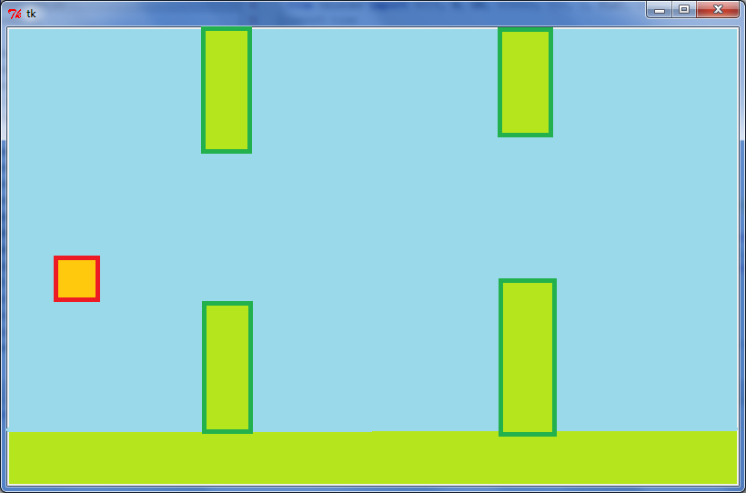
NOTE: These specifications are negotiable. IF you get teacher approval, THEN you can modify them or even make an entirely different game if you wish.

Examples of ways of making a program flexible and robust include: • using actions, conditions, control structures and, methods, functions or procedures effectively • checking input data for validity • correctly handling expected, boundary and invalid cases • using constants, variables and derived values in place of literals.

